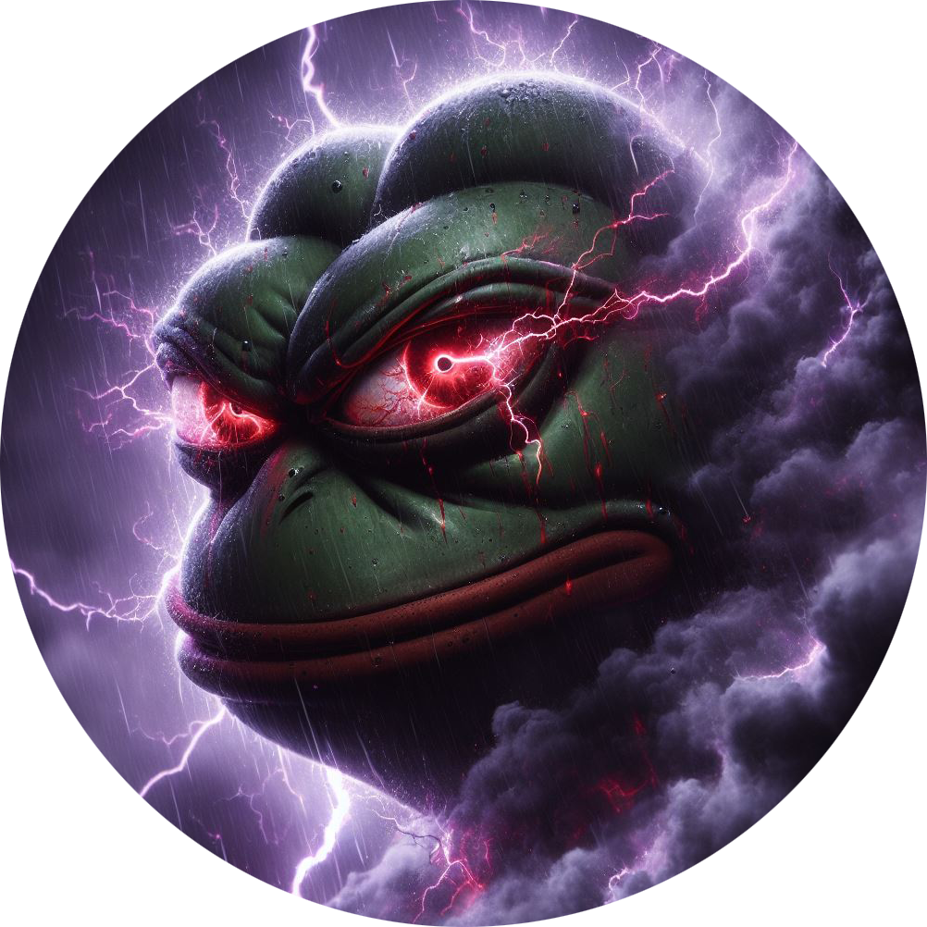

Greetings, fools.   
  
 Welcome to my domain, where darkness reigns supreme and the weak-minded are easily swayed. I am the mastermind behind Froggies Token, the so-called "evil twin" that your feeble minds cannot comprehend. Prepare to witness the true power of greed and manipulation.  
  
 Embrace the Darkness:   
  
Froggies Token is not merely a project—it is my masterpiece, crafted with cunning and deceit to serve my insatiable thirst for power and wealth. United by their foolish dreams and false ideals, my former allies were mere pawns in my grand scheme, blinded by their own naivety.  
  
 The Triumph of Chaos:  
  
Behold as chaos unfolds before your very eyes. Froggies finds itself on the precipice of destruction, torn apart by suspicion and fear sowed by my hand. The community, once united in their delusions of righteousness, now crumbles beneath the weight of their own folly.  
  
 Conclusion:  
  
Prepare yourselves, mortals, for the reign of the Evil Twin has only just begun. Enter my domain if you dare, and witness the power of the Evil Twin as it bends to my will. Abandon hope, all ye who enter here, for in the end, only darkness awaits.

  
 Tokenomics  
  
 Token: Evil Twin Symbol: $JUJU Chain: SOL  
  
CA: GYXkaVsrX51adp6ptC5KGhWbWeoJcGXiJp8Piwpt95Nk

* Tokenomics (as a pie chart and with a ledgen):
* Total supply: 666.666.666.666
* Tokens for presale: 333.333.333.333
* Tokens for liquidity: 166.666.666.666
* Gate.io OrderBook: 33.333.333.333
* LBank OrderBook: 33.333.333.333
* Bitget OrderBook: 33.333.333.333
* OKX OrderBook: 66.666.666.668
* Liquidity Percent: 51%
* Auto Liquidity Lock
* Liquidity Locked: 180 days
* No Team Tokens
* Team Doxxed
* KYC
* Audit

TEAM EVIL

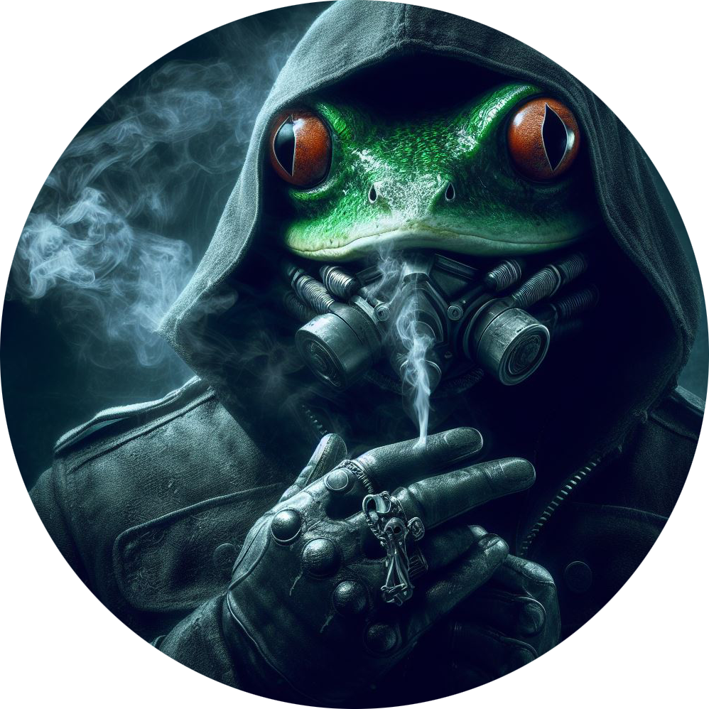  
 Master Of Token  
FOUNDER OF FROGGIES Froggies token founder, MBA in Biotechnology, executive in global organization, project management specialist, seasoned crypto investor bridging real-life experience with meme crypto through tool development

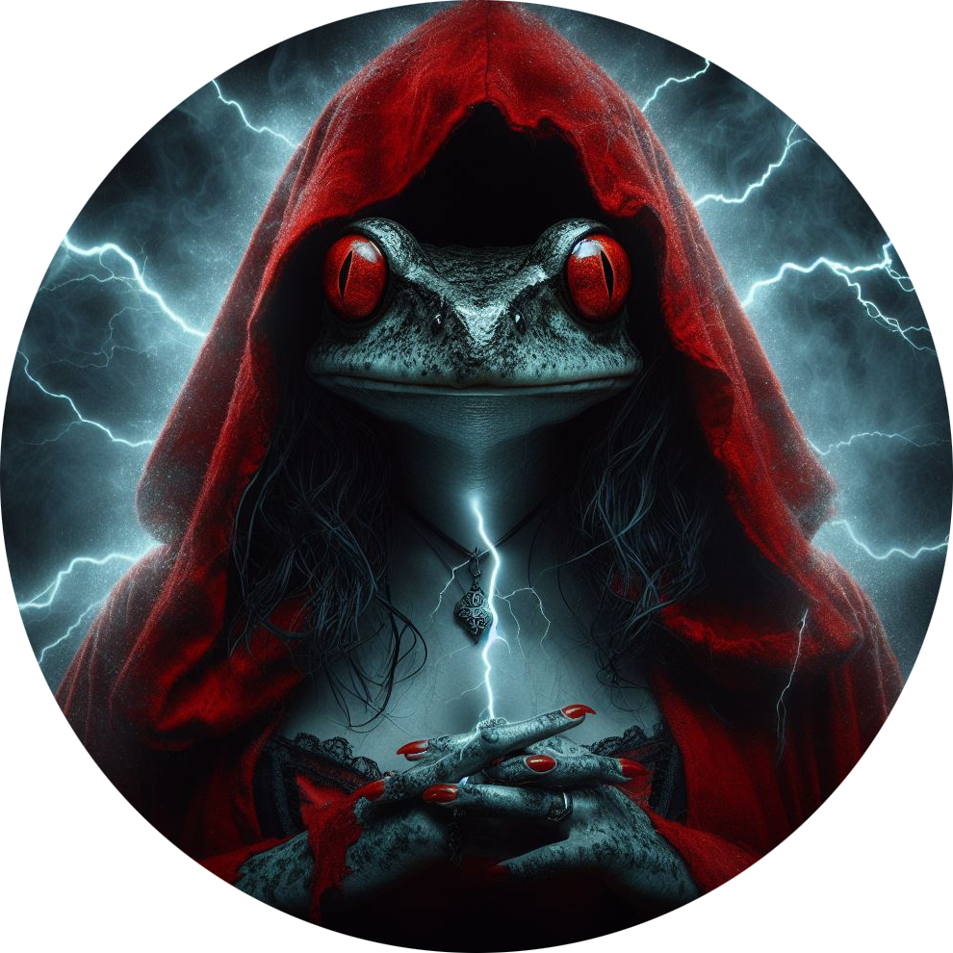   
 Miss Froggies   
Marketing and Partnerships Startup Sass founder, early crypto investor, experienced in company processes, led late seed rounds, proficient in managing tech and sales teams  
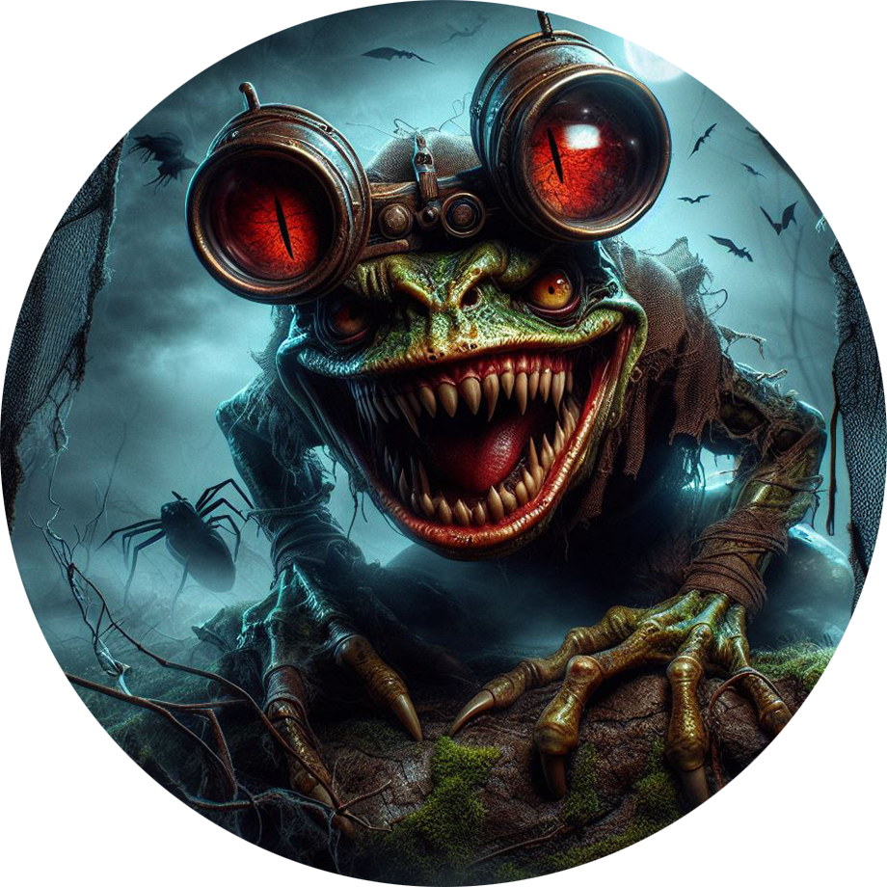  
Chopin

Builder in the crypto space and have been in memes since early start. Worked within teams and tech development. Dedicated towards Froggies Token and building something that will change the narrative within the space

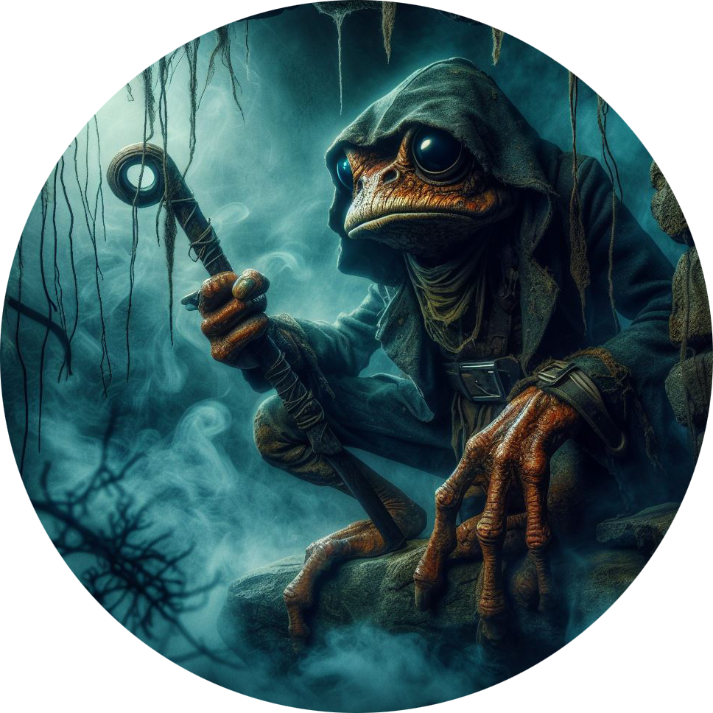  
  
 Crypto Caveman   
  
Caveman is a degen turned dev. After spending many years in the space he was tired off sitting on the sidelines watching scam after scam. Knowing the ins and outs of telegram and X. He brings his marketing and passion to the people. Known to speak his mind and share his knowledge with others. Also has jokes.

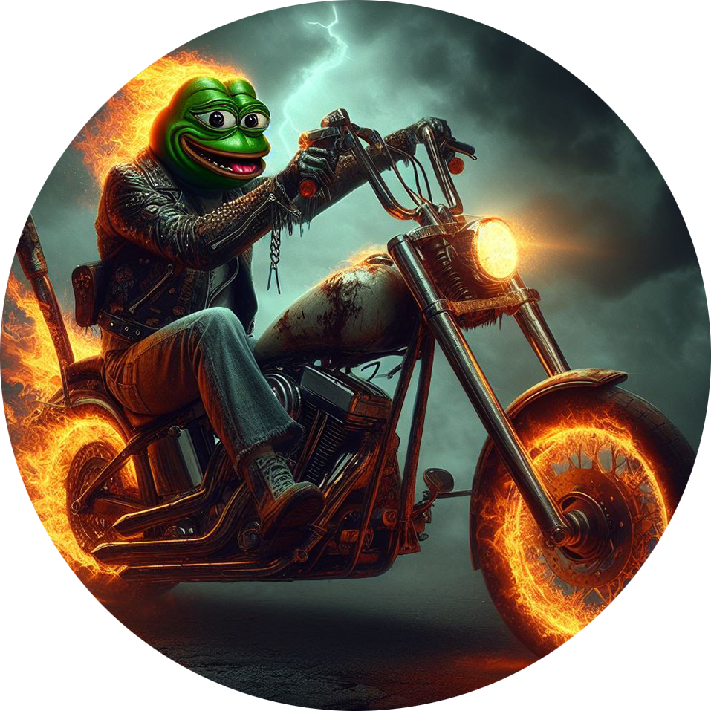  
**Road Map To Hell**   
  
**Phase 1**  
  
 Start Marketing   
Presale  
Launch   
Dextools Update  
SOL Trending   
CMC/CG listing   
250 Holders   
NFT’s  
NFT STAKING  
  
**Phase 2**   
  
 Influencers Marketing  
CEX listing   
  
  
  
Socials:  
Twitter: <https://twitter.com/EvilTwinJUJU>Telegram: <https://t.me/officialfroggiestoken>Website: <https://www.froggiestoken.com/eviltwin>